Guidelines for the compilation of reports
on Species Distribution (SD)
of Invasive Alien Species of Union concern

Contents
1. INTRODUCTION 2
2. DATA PACKAGE: Access and use FOR Reporting 2
3. OVERVIEW OF THE DATA PACKAGE 5
3.1 Data sources 5
3.1.1 Species Distribution 6
3.1.2 Occurrences 6
3.1.3 Metadata 8
4. DATA ON RAPID ERADICATION AND MANAGEMENT FROM NOTSYS 9
5. REFERENCES 10

INTRODUCTION
Commission Implementing Regulation (EU) 2017/1454 of 10 August 2017 [1] specifies the technical formats for reporting by the Member States (MS) pursuant to Regulation (EU) No 1143/2014 (IAS Regulation) [2]. Member State authorities are required to report on the distribution in their territory of each of the invasive alien species (IAS) of Union concern. The following guidance is included in the Implementing Regulation:
“Provide a file with data on the distribution of the species applying Directive 2007/2/EC. This file shall use the spatial object types defined in Section 18 of Annex IV (‘Species Distribution’) of Regulation (EU) No 1089/2010 implementing that Directive. Information on the reproduction and spread patterns shall be specified using appropriate code lists”.
The code lists to be used for providing information on the reproduction and spread patterns is not subject to this Annex. These are included in the “Explanatory Notes and guidelines for the period 2015- 2018”.

DATA PACKAGE: Access and use FOR Reporting
The Commission makes available downloadable data packages at Country level, accessible through a web interface. Data packages content has been extracted from the Joint Research Centre (JRC) European Alien Species Information Network (EASIN) Data Partners’ network [3], the European Alien Species Notification System (EASIN NOTSYS) [4], and baseline reports [5].
The web interface (see Figure 1) is available at the following URL:
https://easin.jrc.ec.europa.eu/easin/Services/reporting
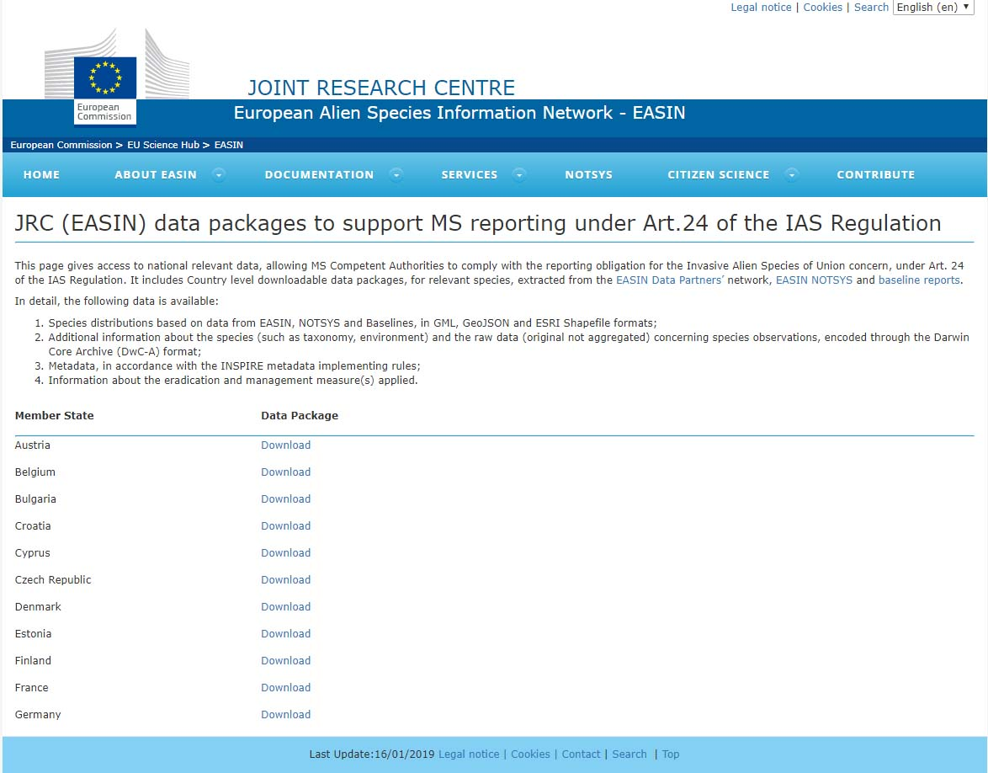
Figure 1 – Web interface from which the data packages to support MS reporting obligations are downloadable (note that the list of countries in this screenshot is incomplete).

Any enquiry about the web interface and the download of the data packages can be addressed to the following email:
JRC-EASIN@ec.europa.eu

Reporting authorities of the MS may use these files as а basis to fulfil their reporting obligations, in particular consider the data provided and update it if needed. To this end, a workflow is presented in the next sections of this document. Reporting authorities may choose any open source or proprietary GIS solution and update their data packages before uploading the distribution maps as part of the IAS report to the Reportnet Central Data Repository (CDR) of the European Environmental Agency (EEA). In step 3, we recommend to use the empty grid template to update the species distribution data (e.g. load the distribution of a species, load the empty grid template, start the editing session). In step 5, possible metadata editors to be used are GeoNetwork and INSPIRE Metadata Editor.

The proposed workflow includes the following steps:
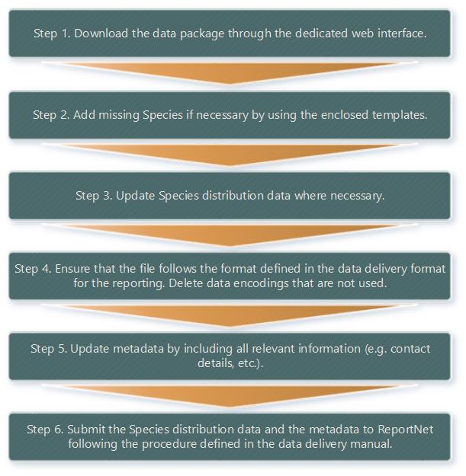
Figure 2 - Proposed workflow for updating the provided data package for reporting.

OVERVIEW OF THE DATA PACKAGE
Geospatial data on the IAS distribution, associated observations and metadata shall, in accordance with Recitals 2 and 3 of Implementing Regulation 2017/1454, and Section A of the “Instructions for compiling the information to be submitted”, be delivered in line with the INSPIRE Directive (2007/2/EC) [6].

This section of the guidelines provides a technical overview of the data package (Figure 3) that is made available to MS.
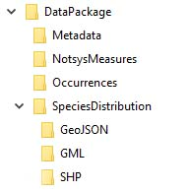
Figure 3 - Structure of the data Package provided to MS.

3.1 Data sources
The following data sources are included in the e-reporting data package:
EASIN
The European Alien Species Information Network (EASIN) collects and indexes spatial data (information) on the distribution of Alien Species occurring in Europe from a network of Data Partners [7]. For each IAS of Union concern, all spatial data aggregated from the EASIN data partners (with exception of NOTSYS and Baseline) are included.
NOTSYS
The European Alien Species Notification System (EASIN NOTSYS) [4] is the official tool allowing Member States to notify the Commission and inform the other Member States as required by the IAS Regulation. In particular, it supports the requirements of Articles 16 (Early detection notifications) and 17 (Rapid eradication at an early stage of invasion) of the IAS Regulation. The data about the reported distributions, per MS, of each species, is provided at the cut-off date of 31st December 2018.

Baseline
An EU geographical distribution of the IAS of Union concern (Commission Implementing Regulations 1141/2016 and 1263/2017) is published in JRC “Science for Policy Reports”, based on the best available knowledge [5]. These reports are the result of an assessment of occurrence and distribution data aggregated through EASIN and submitted for verification to all Member States Competent Authorities.

3.1.1 Species Distribution
The data is encoded in accordance with an extended INSPIRE Species Distribution (SD) Data Model. An extensive overview of the data model is available through a technical guidance document [8].
Individual files are made available per each of the species in three data encodings, GML, JSON (GeoJSON) and SHP (ESRI Shapefile), which are provided in separate sub-folders. The MSs may choose among these, having in view of their expertise or existing national systems, the one that best suits their needs. All Species Distribution datasets, except those encoded in JSON, are represented through the ETRS89/LAEA projection [8] and the species observations are aggregated by 10x10km cells, following the specifications of the EEA Reference Grid [10].
Each data encoding includes also an empty grid template file covering the country territory to be used by the MS in preparation of the reporting.
The GML and GeoJSON sub-folders contain separate files for species and data source, while the SHP sub-folder contains separate files for species only.

3.1.2 Occurrences
The sub-folder ‘Occurrences’ includes additional information about the species (such as Taxonomy, Environment) and the raw (original not aggregated) species observations encoded through the Darwin Core Archive (DwC-A) format [11]; i.e. comma separated values text file (CSV) with the individual records. These data are meant to provide the MS with additional material to facilitate them in compiling their reports, but they are outside the scope of the information needed to be filled in the report.

The following DwC-A terms are included for the occurrences data files:
Term | Description
datasetName | Type of data source (EASIN, NOTSYS, BASELINE).
locationAccordingTo | Provides the name of the EASIN data partner.
institutionCode | Original source of the data as provided by the EASIN data partner.
relatedResourceID | Identifier of the EEA grid cell id.
basisOfRecord | The specific nature of the data record. The default value is "HumanObservation".
scientificNameID | EASIN identifier for the nomenclatural (not taxonomic) details of a scientific name.
scientificName | The scientific name of the species.
kingdom | The full scientific name of the kingdom in which the taxon is classified.
phylum | The full scientific name of the phylum or division in which the taxon is classified.
class | The full scientific name of the class in which the taxon is classified.
order | The full scientific name of the order in which the taxon is classified.
family | The full scientific name of the family in which the taxon is classified.
isMarine | Indicates whether the taxon is a marine organism, i.e. can be found in/above seawater.
isFreshwater | Indicates whether the taxon occurs in freshwater habitats, i.e. can be found in/above rivers or lakes.
isTerrestrial | Indicates whether the taxon is a terrestrial organism, i.e. occurs on land as opposed to the sea.
countryCode | The standard two-digit code for the country in which the location occurs.
year | The four-digit year in which the event occurred.
decimalLatitude | The geographic latitude in decimal degrees (EPSG: 4326).
decimalLongitude | The geographic longitude in decimal degrees (EPSG: 4326).
footprintWKT | Coordinates expressed in WKT [13] format and in decimal degrees (EPSG: 4326).

3.1.3 Metadata
The metadata sub-folder is made available in accordance with the INSPIRE metadata implementing rules [12]. A metadata file is made available per Country for each species. The following metadata elements have been populated:
Metadata element | Description
Resource title | A unique name by which the resource is known.
Resource abstract | A brief narrative summary of the content of the resource.
Resource type | The type of resource described by the metadata. Please refer to element gmd:MD_ScopeCodecodeList (Member State don’t need to change this value).
Resource locator | Link to additional information about the resource.
Unique resource identifier | A value uniquely identifying the resource.
Resource language | The language(s) used within the resource limited to the languages defined in ISO 639-2.
Topic category | A high-level classification scheme to assist in the grouping and topic-based search of available spatial data resources.
Keyword | Dataset is tagged as an “INSPIRE priority data set” in accordance with [14]
Geographic bounding box | The extent of the resource in the geographic space, given as a bounding box and referring the ETRS89/LAEA (or EPSG: 3035) coordinate reference system
Temporal reference | Information on the temporal dimension of the data.
Lineage | A statement on process history and/or overall quality of the spatial data set.
Spatial resolution | The level of detail of the data set expressed through the equivalent map scale.
Conformity | Conformity to EU legislation. Please refer to elements gmd:DQ_DomainConsistency for both INSPIRE and Article 24 point 1 off Regulation 1143.2014 in IAS
Conditions for access and use | Defines the conditions for access and use of spatial data.
Limitations on public access | When Member States limit public access to spatial data sets and spatial data services under Article 13 of Directive 2007/2/EC, this metadata element shall provide information justifying the limitations. If there are no limitations on public access, this metadata element shall indicate it.
Responsible organisation | Description of the organisation responsible for the establishment, management, maintenance and distribution of the resource.
Metadata point of contact | Description of the organisation responsible for the creation and maintenance of the metadata.
Metadata date | The date which specifies when the metadata record was created or updated.  This date shall be expressed in conformity with ISO 8601.
Metadata language | The language in which the metadata elements are expressed in conformity with ISO 639-2.

In preparation of the reporting, MS need to update the elements highlighted in grey. In the description of “Resource abstract”, MSs are invited to enter the following sentence: “Distribution data for the reporting under the IAS regulation (EU No 1143/2014) for the report period “2015-2018”.
An additional single (one per Member State) Metadata file template is added to the package to ease MS work. The MS can use placeholders to insert their data. Please note: any date must be in the short form of yyyy-mm-dd.

DATA ON RAPID ERADICATION AND MANAGEMENT FROM NOTSYS
Information about the rapid eradication measures for the species of Union concern are contained in the folder “NotsysMeasures” for those MS that have made such notifications. This information is structured as XML files. The XML with the data currently available in NOTSYS can be handled by MS using any suitable reading/editing tool (e.g. XML Notepad, XMLSpy). The information can then be used to respond to the relevant questions in the EEA reporting tool (points 11 to 13 of the Commission Implementing Regulation specifying the technical formats for reporting by the Member States [1]).

The following fields are included:
Field | Description
EradMeasureId | Unique NOTSYS identifier of the rapid eradication and management measure.
CountryCode | The standard two-digit code for the country that reported the measure.
SpeciesId | EASIN identifier of the species object of measure.
SpeciesName | Scientific name of the species object of measure.
StartingDate | Starting date of the measure.
EstimatedMeasureDuration | Estimated duration of the measures (numeric value).
DurationType | Type of duration of the measures (e.g. “months”).
EndOfMeasureDate | End date of the measure (if available).
Title | Title of the measure.
MeasureDescription | Description of the measure.
SideEffects | Side effects of the measure (if available).
EffectDescription | Description of the effectiveness (if available).
OverallMeasureCost | Overall measure cost of the measure (if available).

REFERENCES
- COMMISSION IMPLEMENTING REGULATION (EU) 2017/1454 of 10 August 2017 specifying the technical formats for reporting by the Member States pursuant to Regulation (EU) No 1143/2014 of the European Parliament and of the Council
- Commission Regulation (EU) No 1143/2014 on the prevention and management of the introduction and spread of invasive alien species https://eur-lex.europa.eu/legal-content/EN/TXT/PDF/?uri=CELEX:32014R1143&from=BG
- https://easin.jrc.ec.europa.eu/Partners/Partners
- https://easin.jrc.ec.europa.eu/notsys
- https://easin.jrc.ec.europa.eu/Documentation/Baseline
- Directive 2007/2/ of 14 March 2007 establishing an Infrastructure for Spatial Information in the European Community (INSPIRE). https://eur-lex.europa.eu/legal-content/EN/TXT/?uri=CELEX:32007L0002
- https://easin.jrc.ec.europa.eu/GeoDatabase
- INSPIRE Data Specification for the spatial data theme Species Distribution. https://inspire.ec.europa.eu/id/document/tg/sd
- EPSG:3035 overview http://spatialreference.org/ref/epsg/etrs89-etrs-laea
- EEA reference grid https://www.eea.europa.eu/data-and-maps/data/eea-reference-grids-2
- Darwin Core Archive http://tools.gbif.org/dwca-assistant
- Commission Regulation (EU) No 1311/2014 of 10 December 2014 amending Regulation (EC) No 976/2009 as regards the definition of an INSPIRE metadata element https://eur-lex.europa.eu/legal-content/EN/TXT/?uri=uriserv%3AOJ.L_.2014.354.01.0006.01.ENG
- Well Know Text https://en.wikipedia.org/wiki/Well-known_text_representation_of_geometry
- Implementation guidance and support for the tagging of priority datasets for INSPIRE. https://ies-svn.jrc.ec.europa.eu/projects/2016-5/wiki/Implementation

The baseline report of the first update of the list of IAS of Union concern is currently under review and will be published soon.
GeoJSON supports only the WGS84 – EPSG 4326 projection. MS can chose from an array of GIS tools, such ArcGIS or QuantumGIS, to transform this projection in the in ETRS89/LAEA projection.
Please follow the links to the DwC-A quick reference guide for a complete definition and examples of the terms used.

